**Unit 2- Working with Evidence: Working Conditions**

**Language and Literature Level 2**

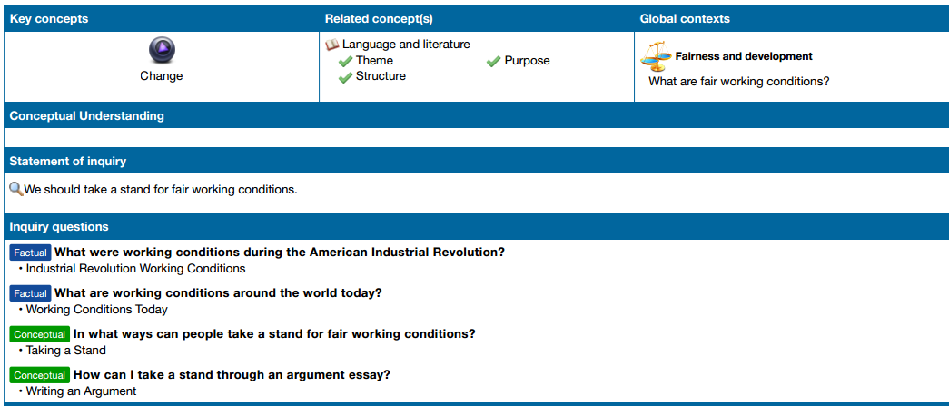

**Summative Assessment**

**Consumer’s Guide to Working Conditions in the Garment Industry**

**Your Task:** To create a “Consumer’s Guide to Working Conditions in the Garment Industry.” You will work with a partner to create a guide that draws on your knowledge of the Industrial Revolution as well as current working conditions in the garment industry. You will publish this document as a brochure as well as create a poster to share your research.

Name___________________________________ Criterion A: Analysing

|  |  |  |
| --- | --- | --- |
| Achievement  Level | Level  Descriptor | Indicators |
| 0 | The student does not reach a standard described by any of the descriptors below. |  |
| 1-2 | The student:   * provides **minimal** identification or explanation of the content, context, language, structure, technique and style, and **does not** explain the relationships among texts * provides **minimal** identification and explanation of the effects of the creator’s choices on an audience * **rarely** justifies opinions and ideas with examples and explanations; uses little or no terminology * interprets **few** similarities and differences in features within and between genres and texts |  |
| 3-4 | The student:   * provides **adequate** identification and explanation of the content, context, language, structure, technique and style, and **some explanation** of the relationships among texts * provides **adequate** identification and explanation of the effects of the creator’s choices on an audience * justifies opinions and ideas with **some** examples and explanations, though this may not be consistent; uses some terminology * interprets **some** similarities and differences in features within and between genres and texts |  |
| 5-6 | The student:   * provides **substantial** identification and explanation of the content, context, language, structure, technique and style, and explains the relationships among texts * provides **substantial** identification and explanation of the effects of the creator’s choices on an audience * **sufficiently** justifies opinions and ideas with examples and explanations; uses accurate terminology * consistently interprets similarities and differences in features within and between genres and texts |  |
| 7-8 | The student:   * provides **perceptive** identification and explanation of the content, context, language, structure, technique and style, and explains the relationships among texts **thoroughly** * provides **perceptive** identification and explanation of the effects of the creator’s choices on an audience * gives **detailed justification** of opinions and ideas with **a range** of examples and thorough explanations; uses **accurate** terminology * **perceptively compares and contrasts** features within and between genres and texts |  |

Name___________________________________ Criterion C: Producing Text

|  |  |  |
| --- | --- | --- |
| Achievement  Level | Level  Descriptor | Indicators |
| 0 | The student does not reach a standard described by any of the descriptors below. |  |
| 1-2 | The student:   * produces texts that demonstrate a **limited** personal engagement with the creative process; demonstrates a **limited** degree of thought, imagination or sensitivity and **minimal** exploration and consideration of new perspectives and ideas * makes **minimal** stylistic choices in terms of linguistic, literary and visual devices, demonstrating **limited** awareness of impact on an audience * selects **few relevant** details and examples to develop ideas |  |
| 3-4 | The student:   * produces texts that demonstrate **adequate** personal engagement with the creative process; demonstrates **some** degree of thought, imagination or sensitivity and **some** exploration and consideration of new perspectives and ideas * makes **some** stylistic choices in terms of linguistic, literary and visual devices, demonstrating **adequate** awareness of impact on an audience * selects **some** relevant details and examples to develop ideas |  |
| 5-6 | The student:   * produces texts that demonstrate **considerable** personal engagement with the creative process; demonstrates **considerable** thought, imagination and sensitivity and **substantial** exploration and consideration of new perspectives and ideas * makes **thoughtful s**tylistic choices in terms of linguistic, literary and visual devices, demonstrating **good** awareness of impact on an audience * selects **sufficient** relevant details and examples to develop ideas |  |
| 7-8 | The student:   * produces texts that demonstrate **a high degree** of personal engagement with the creative process; demonstrates **a high degree of** thought, imagination and sensitivity and **perceptive** exploration and consideration of new perspectives and ideas * makes **perceptive s**tylistic choices in terms of linguistic, literary and visual devices, demonstrating **clear** awareness of impact on an audience * selects **extensive** relevant details and examples to develop ideas with precision |  |